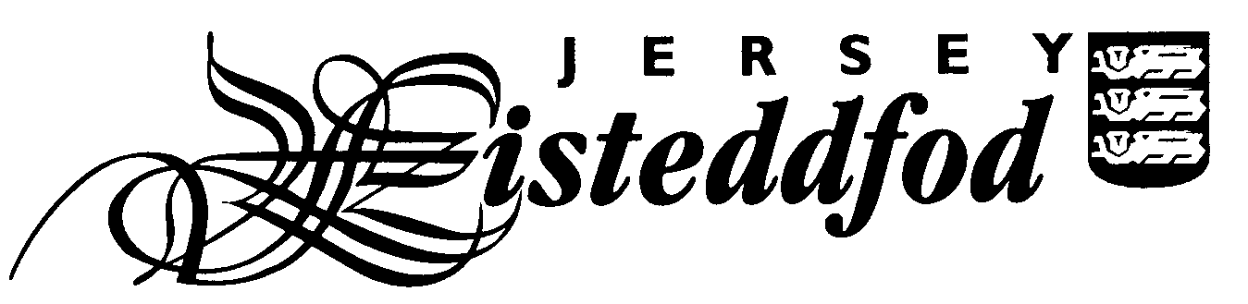
ENTRY FORM – SECTION DU JÈRRIAIS
For official use only
Competitor No.
JUNIOR INDIVIDUAL ENTRIES

Entries close Friday 27th September 2019

PLEASE USE BLOCK CAPITALS

Full Name of Competitor: _________________________________________________________________

School: ________________________________________________________________________________

Age on 31st August 2019: ____________

Please complete the table below indicating which class numbers your child is entering as an individual and the pieces they are performing.

There is an entry fee of £1 for each individual entry.

Class No | Title of Piece | Entry Fee
Total Fee
Please tick to give permission for photographs to appear in the local media

Please tick to confirm you have read the Festival Rules *

Please tick to confirm you have read the Jersey Eisteddfod Privacy Statement *

Signature of Parent: _____________________________________________________

Contact email address: ____________________________________________________________________

Please return this form with the entry fee to your child’s Jèrriais teacher. Please make all cheques payable to ‘The Jersey Eisteddfod’.

If your child has chosen to enter an ‘own choice’ class please ensure you enclose a copy of the piece they have chosen to perform for the adjudicator.

* You can find the Jersey Eisteddfod Privacy Statement and Festival Rules on the Jersey Eisteddfod website www.jerseyeisteddfod.org.je. If you do not have access to the internet you can obtain a paper copy from the teaching team at L’Office du Jèrriais.

